1.Process synchronization

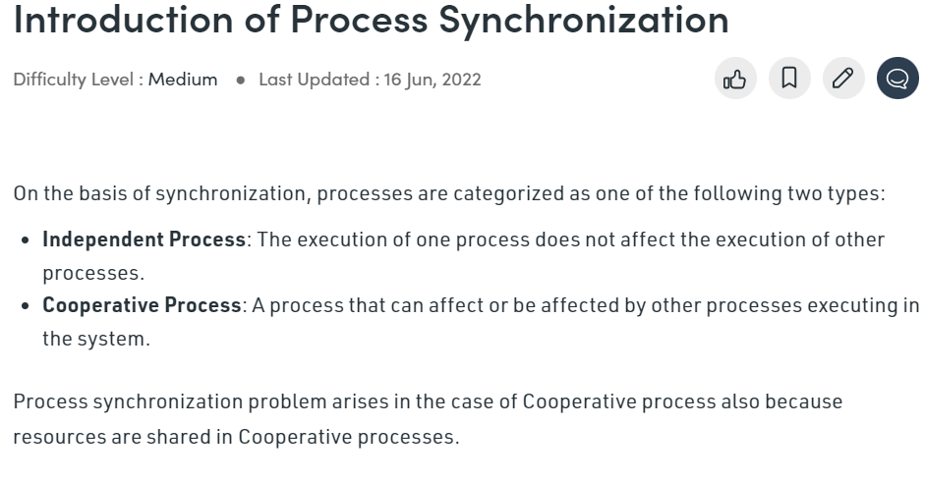

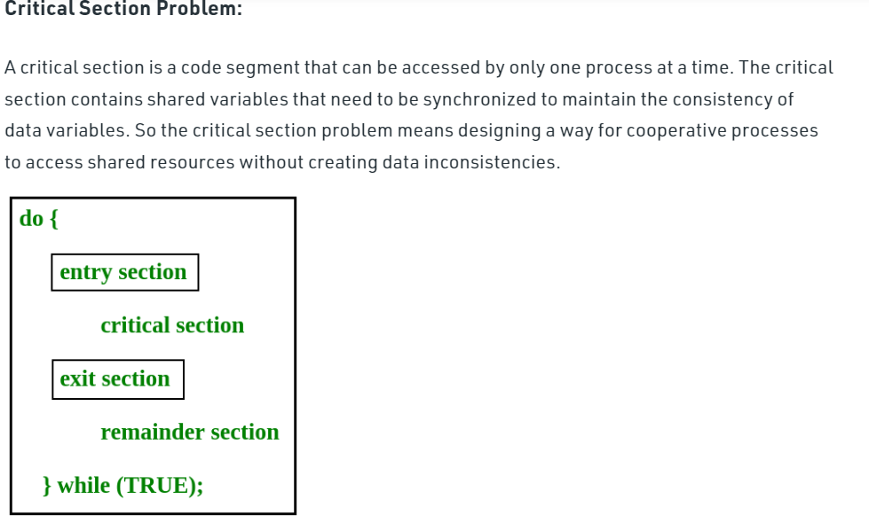

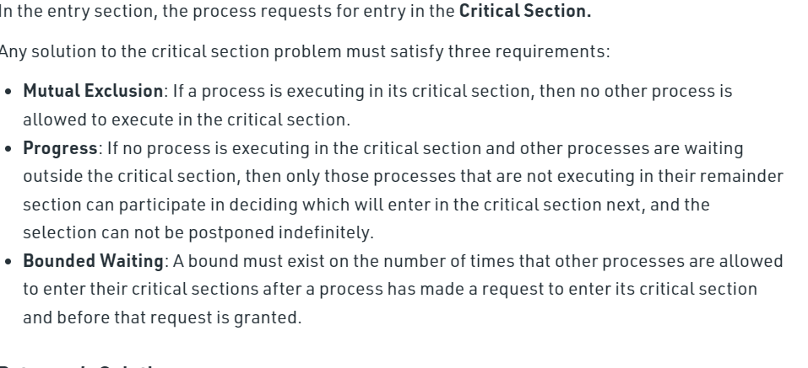

3.process scheduling

<https://youtu.be/pro8cU5Uzdg>

4.threads

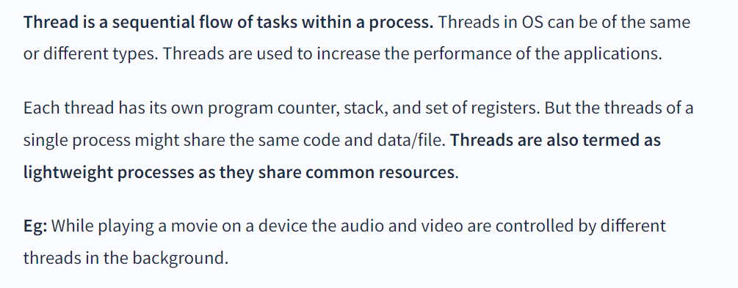

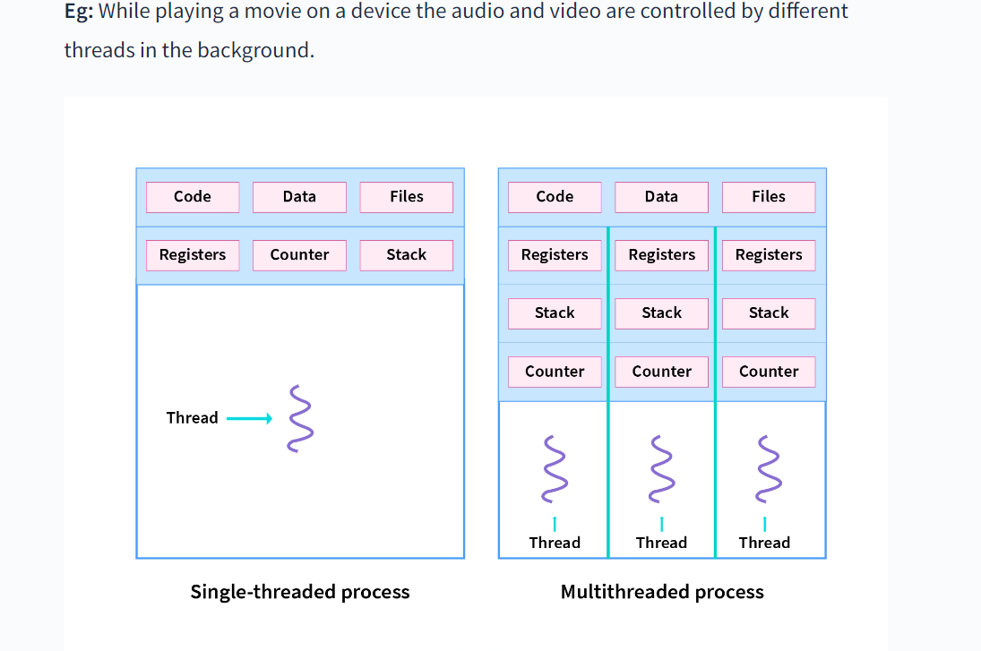

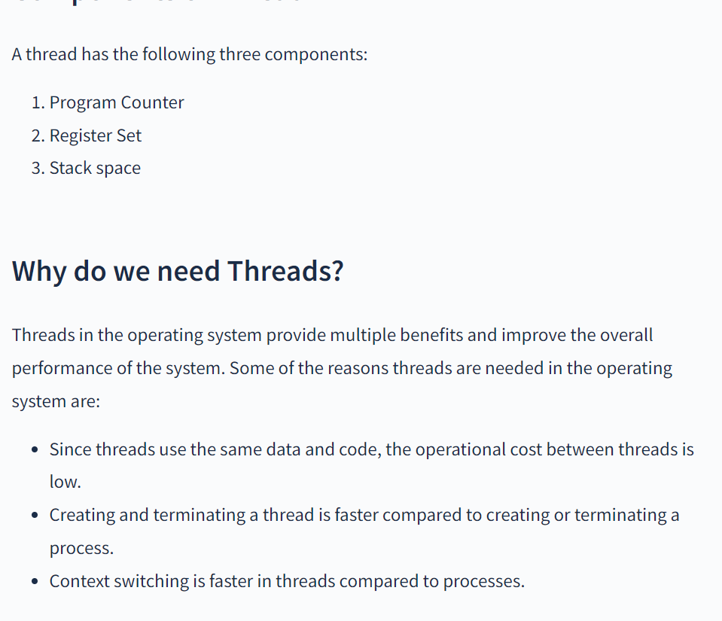

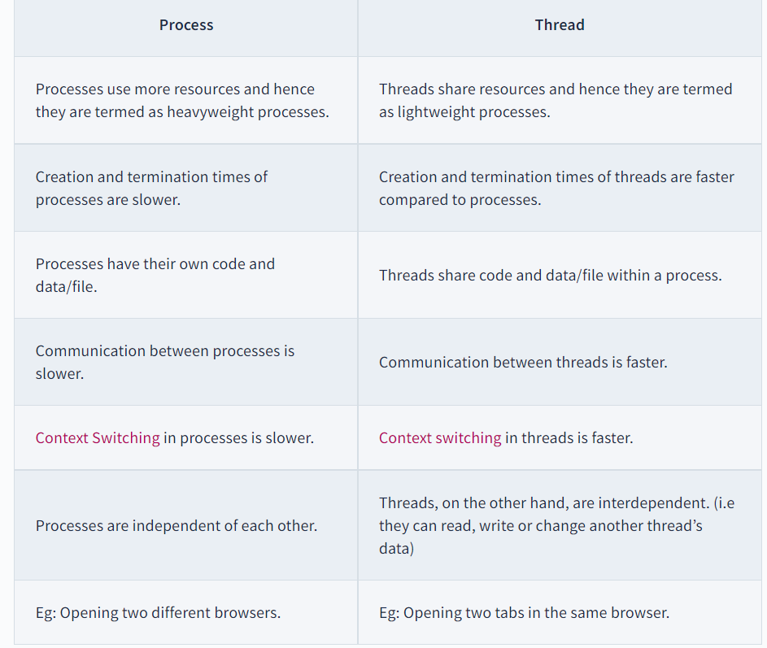

Scheduling problem

Fcfs

<https://youtu.be/WYo1SpUh9FI>

sjn

<https://youtu.be/pYO-FAg-TpQ>

sjrt

<https://youtu.be/_QcX99B-zbU>

round robin

<https://youtu.be/-jFGYDfWkXI>

deadlock

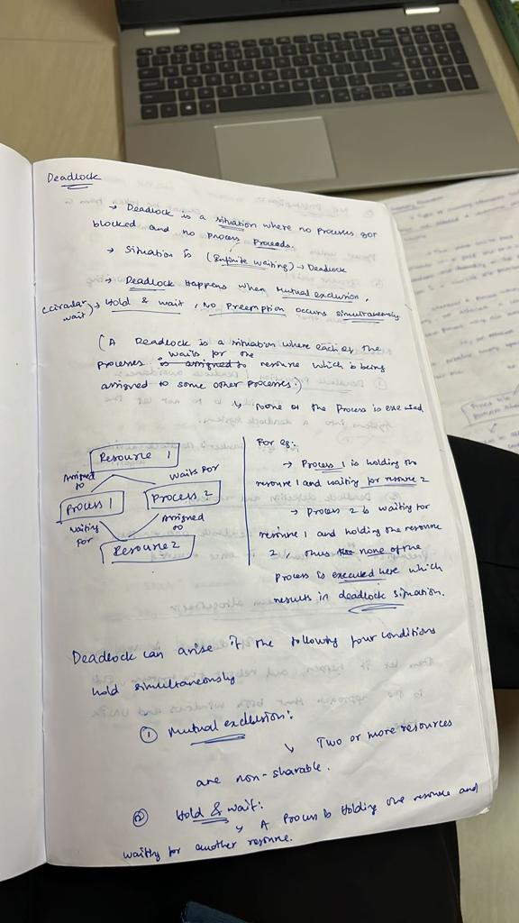

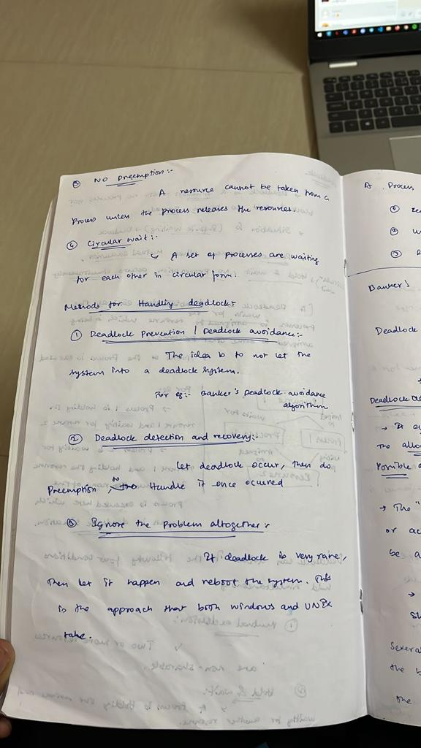

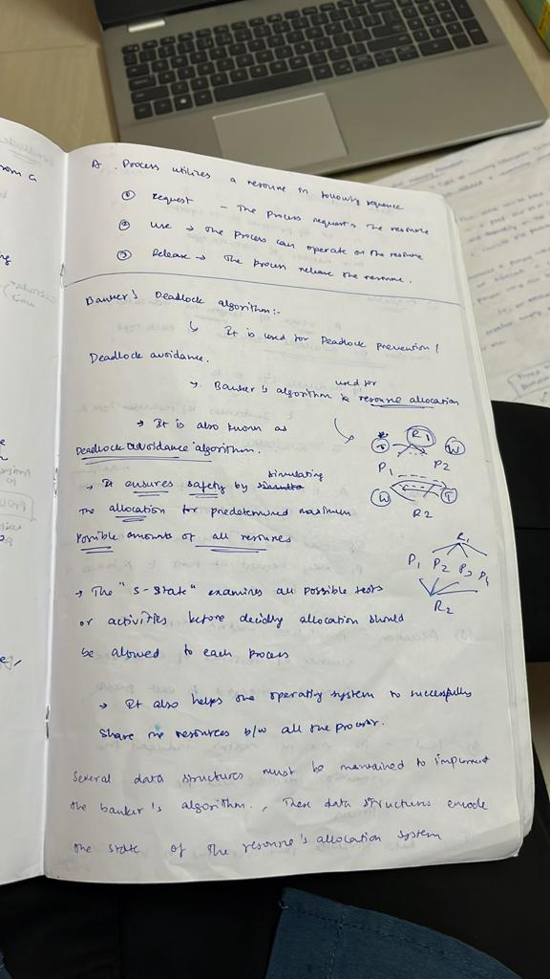

Memory management

<https://youtu.be/W0068fRJTGQ>

file allocation

<https://youtu.be/gK6L3v1b8AM>

Page segmentation

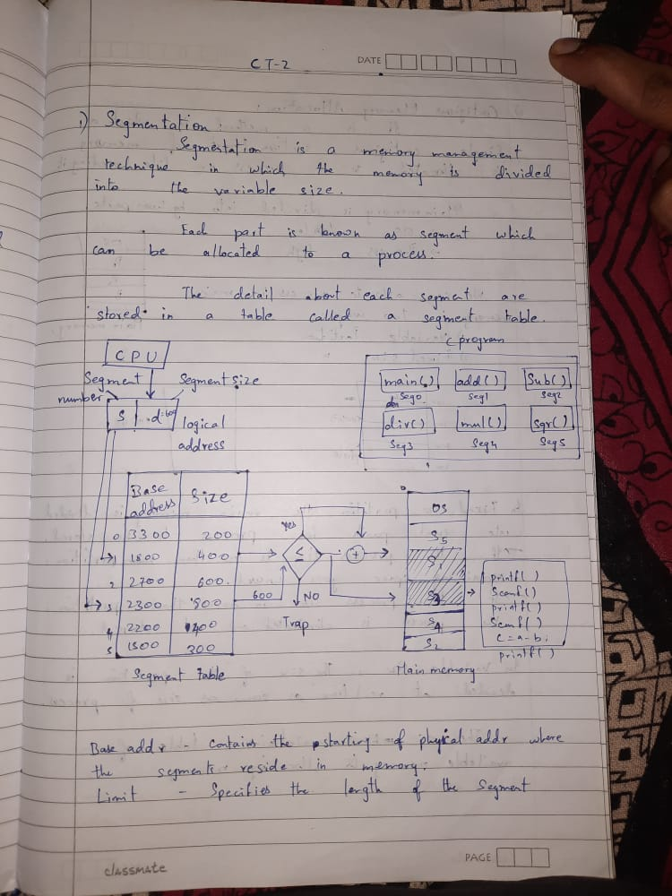

Virtual memory

<https://youtu.be/NPhcwfnYZd8>

demand paging

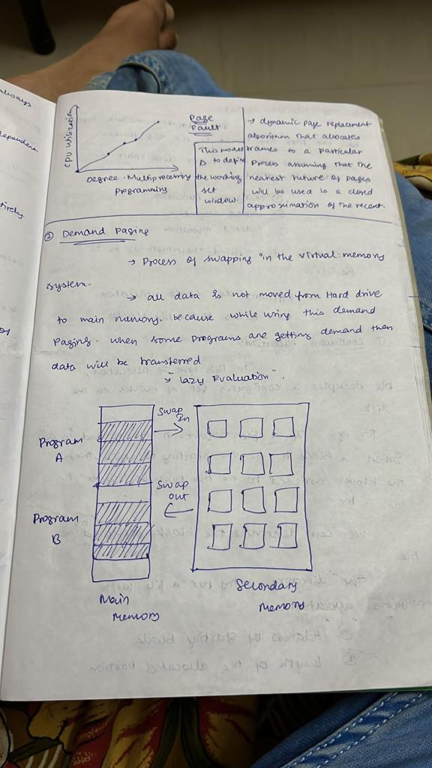

Page replacement algorithm

<https://youtu.be/-gm8oYxJbJw>

Disc scheduling

<https://youtu.be/u_ggRGYU8sg>

File system implementation

<https://youtu.be/t8Rs9AbqHUc>